Churn prediction documentation
Team members:
Mariam Mohamed Goda (Team leader)
Jana Mamdouh Hassan
Mariam Hamed Salem
Youseif Samir Shabaan
→Dataset: https://www.kaggle.com/datasets/blastchar/telco-customer-churn The dataset predicts behavior to retain customers.
Content
Each row represents a customer, each column contains customer’s attributes described on the column Metadata.
The data set includes information about:
- Customers who left within the last month – the column is called Churn
- Services that each customer has signed up for – phone, multiple lines, internet, online security, online backup, device protection, tech support, and streaming TV and movies
- Customer account information – how long they’ve been a customer, contract, payment method, paperless billing, monthly charges, and total charges
- Demographic info about customers – gender, age range, and if they have partners and dependents
Attribute | Description | Possible Values / Type
customerID | Unique identifier for each customer | String
gender | Customer's gender | Male, Female
SeniorCitizen | Indicates whether the customer is a senior citizen | 0 = No, 1 = Yes

Attribute | Description | Possible Values / Type
Partner | Whether the customer has a partner | Yes, No
Dependents | Whether the customer has dependents | Yes, No
tenure | Number of months the customer has stayed with the company | Integer (Months)
PhoneService | Whether the customer has a phone service | Yes, No
MultipleLines | Whether the customer has multiple phone lines | Yes, No, No phone service
InternetService | Customer's internet service provider | DSL, Fiber optic, No
OnlineSecurity | Whether the customer has online security service | Yes, No, No internet service
OnlineBackup | Whether the customer has online backup service | Yes, No, No internet service
DeviceProtection | Whether the customer has device protection | Yes, No, No internet service
TechSupport | Whether the customer has technical support | Yes, No, No internet service
StreamingTV | Whether the customer subscribes to streaming TV | Yes, No, No internet service
StreamingMovies | Whether the customer subscribes to streaming movies | Yes, No, No internet service
Attribute | Description | Possible Values / Type
Contract | Customer's contract type | Month-to-month, One year, Two year
PaperlessBilling | Whether paperless billing is enabled | Yes, No
PaymentMethod | Customer's payment method | Electronic check, Mailed check, Bank transfer (automatic), Credit card (automatic)
MonthlyCharges | Monthly amount charged to the customer | Float
TotalCharges | Total amount charged to the customer | Float
Churn (Target Variable) | Indicates whether the customer left the company | Yes, No

→Milestones :
Milestone 1: In this milestone we focused on preprocessing the data :
1st : Data loading & initial overview: We loaded the data from Kaggle, and we found that the data has 21 columns: 1 of type float , 2 of type int and 18 of type object
2nd : analyzing the data: we didn’t find any null values and no duplicates, but we found garbage values
We fixed the “total charges “column because it has Nan values, so we first convert it to numerical values and then fill the blanks with 0.
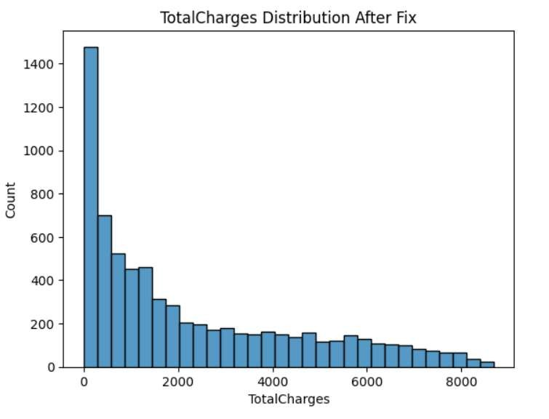
Regarding the Imbalance classes:
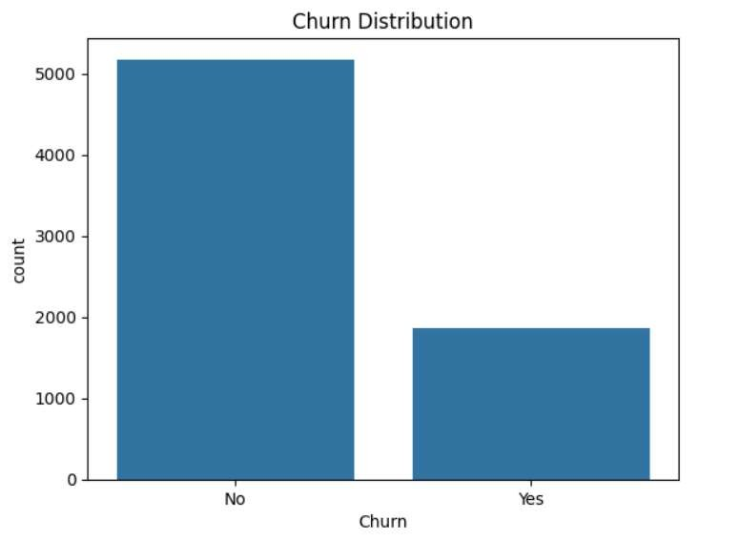
The dataset is imbalanced, meaning one class ("No") has significantly more samples than the other ("Yes").
Although the imbalance is not extreme, it is important because:
- A machine learning model could become biased toward predicting "No".
3rd feature extraction using sql:
→ We found 73.46% stayed and 26.54% churned
Query Results
Contract Type Total Customers Churned Customers Churn Rate
Month-to-month 3,875 | 1,655 | 42.71%
One year 1,473 | 166 | 11.27%
Two year 1,695 | 48 | 2.83%
•Month-to-month contracts have the highest churn rate (42.71%). Nearly 4 out of every 10 customers with a monthly contract left the company. This suggests that customers without a long-term commitment are much more likely to switch providers.
- Customers with a one-year contract have a much lower churn rate of 11.27%, indicating that longer commitments improve customer retention.
- Two-year contracts have the lowest churn rate (2.83%), meaning almost all customers with long-term contracts remain with the company.

→The results reveal a strong negative relationship between contract length and customer churn. As the contract duration increases, the likelihood of a customer leaving the company decreases significantly.
This suggests that contract type is one of the strongest predictors of customer churn in the dataset.
Query Results
Internet Service | Total Customers | Churned Customers | Churn Rate
Fiber optic | 3,096 | 1,297 | 41.89%
DSL | 2,421 | 459 | 18.96%
No Internet | 1,526 | 113 | 7.40%

- Fiber optic customers have the highest churn rate (41.89%). Nearly 42% of customers using fiber optic internet left the company. This is more than twice the churn rate of DSL customers and almost six times that of customers without internet service.
- DSL customers have a moderate churn rate (18.96%). While some customers leave, they are considerably more likely to stay compared to fiber optic users.
- Customers with no internet service have the lowest churn rate (7.40%), indicating that they are the most loyal group in the dataset.
The analysis suggests that internet service type is strongly associated with customer churn. In particular, Fiber optic customers are the most likely to leave the company. →Query Results
Churn Status | Avg. Monthly Charges | Avg. Total Charges | Avg. Tenure (Months)
No | 61.27 | 2549.91 | 37.57
Yes | 74.44 | 1531.80 | 17.98
Interpretation
- Monthly Charges
  - Customers who churned paid an average of 74.44 per month.
  - Customers who stayed paid an average of 61.27 per month.
Observation:
Customers with higher monthly charges are more likely to leave the company.

- Total Charges
  - Customers who stayed paid an average total of 2,549.91.
  - Customers who churned paid only 1,531.80 on average.
Observation:
Although churned customers pay more each month, they have lower total charges because they remain with the company for a shorter period.

- Customer Tenure
  - Customers who stayed have an average tenure of 37.57 months.
  - Customers who churned stayed for only 17.98 months on average.
Observation:
Customers who leave tend to do so relatively early in their relationship with the company.

Business Insight
The analysis reveals three important patterns:
  - Customers with higher monthly bills are more likely to churn.
  - Customers who churn have much shorter tenures, indicating that the first few months are critical for customer retention.
  - Since they leave earlier, churned customers accumulate lower total charges despite paying more per month.

→Query Results
Customer ID | Tenure (Months) | Monthly Charges | Contract | Churn
3292-PBZEJ | 11 | 111.40 | Month-to-month | No
9851-KIELU | 10 | 110.10 | Month-to-month | Yes
3992-YWPKO | 6 | 109.90 | Month-to-month | Yes
5760-IFJOZ | 3 | 107.95 | Month-to-month | No
2081-VEYEH | 3 | 107.95 | Month-to-month | No
1400-MMYXY | 3 | 105.90 | Month-to-month | Yes
3389-YGYAI | 8 | 105.50 | Month-to-month | Yes
5052-PNLOS | 3 | 105.35 | Month-to-month | Yes
6734-GMPVK | 5 | 105.30 | Month-to-month | No
4587-VVTOX | 6 | 105.30 | Month-to-month | Yes
Interpretation
Several common characteristics can be observed among these customers:
  - All customers have month-to-month contracts, the contract type with the highest churn rate in the dataset.
  - Their monthly charges exceed $105, which is significantly higher than the overall average monthly charge.
  - Most have been customers for less than one year, indicating short tenure.
  - Among these ten customers, 6 have already churned, while 4 remain active, suggesting that the active customers share many of the same risk factors and may be likely to churn if no retention efforts are made.
Business Insight
This analysis highlights a customer segment that deserves special attention. Customers who are new, pay high monthly fees, and are on month-to-month contracts appear to have a much higher likelihood of leaving the company.
→Query 6: Churn Rate by Payment Method
Business Insights
The analysis shows that payment method has a significant impact on customer churn.
Customers who pay using Electronic Check have the highest churn rate (45.29%), which is nearly three times higher than customers using automatic payment methods. In contrast, customers who pay through Credit Card (Automatic) and Bank Transfer (Automatic) have the lowest churn rates (15.24% and 16.71%, respectively).
This suggests that customers enrolled in automatic payment methods are generally more loyal and less likely to discontinue the service.
→Query 7: Senior Citizens Churn Rate
Business Insights
Senior citizens have a substantially higher churn rate (41.68%) compared to nonsenior customers (23.61%).
→Query 8: Number of Services per Customer
Business Insights
A new feature called total_services was created to measure customer engagement by counting the number of subscribed services.
Customers with the maximum number of subscribed services (8 services) are all active customers (Churn = No) in the sample shown. This suggests that customers who subscribe to multiple services tend to be more engaged with the company and are less likely to churn.

→A new feature called total_services was created by counting the number of subscribed services for each customer, including phone service, multiple lines, online security, online backup, device protection, technical support, streaming TV, and streaming movies.
This feature represents the customer's level of engagement with the company's services. Customers with a higher number of subscribed services are generally more invested in the company's offerings and are expected to have a lower likelihood of churning.
The new feature was successfully merged into the main dataset, allowing it to be used in subsequent exploratory analysis and predictive modeling.

4th .Exploratory Data Analysis
→We dropped ‘customerID’ column so the final columns
# Demographics
'gender', 'SeniorCitizen', 'Partner', 'Dependents',
# Services
'PhoneService', 'MultipleLines', 'InternetService',
'OnlineSecurity', 'OnlineBackup', 'DeviceProtection',
'TechSupport', 'StreamingTV', 'StreamingMovies',
# Billing
'Contract', 'PaperlessBilling', 'PaymentMethod'
→we found that ‘gender ‘ is the most weak column
→we found that StreamingTV,StreamingMovies,MultipleLines,PhoneService are weak predictors
→Data integration and visualization:
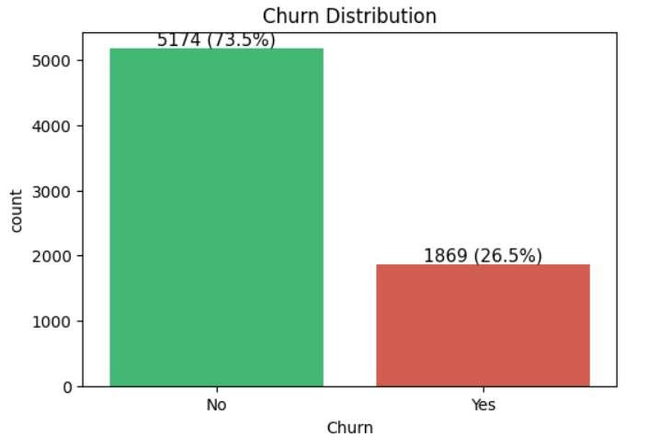

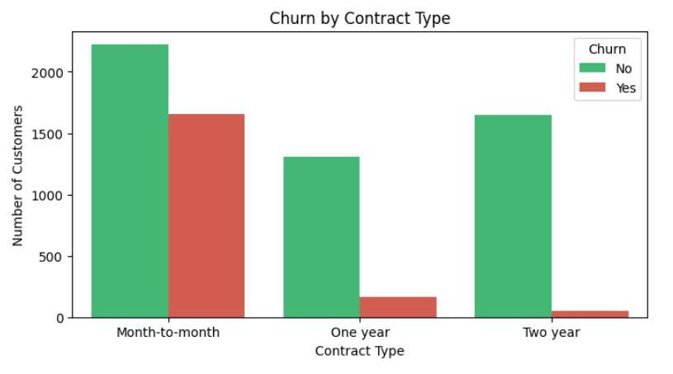
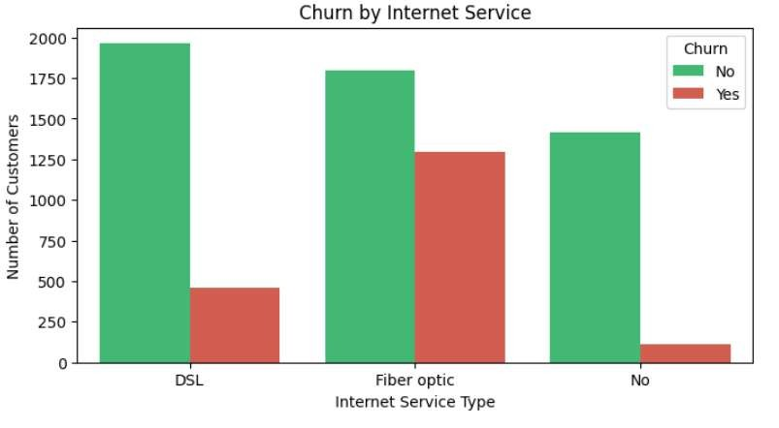

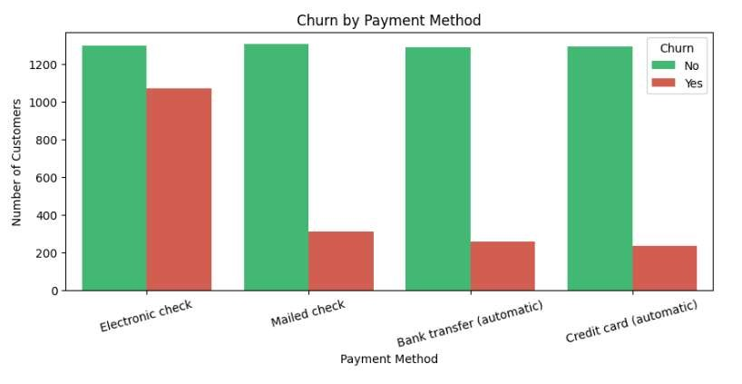
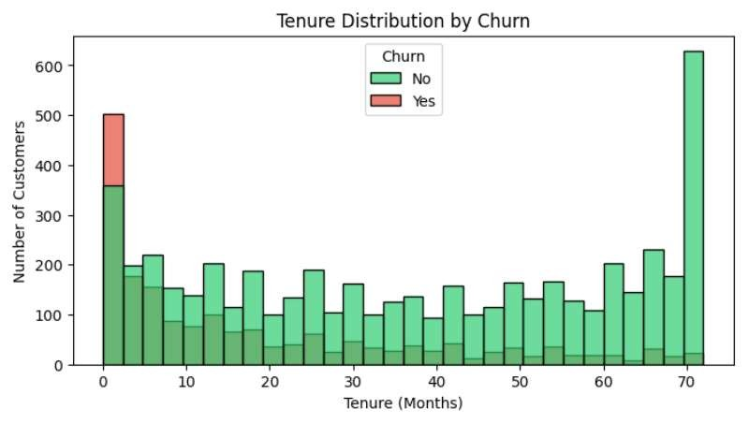
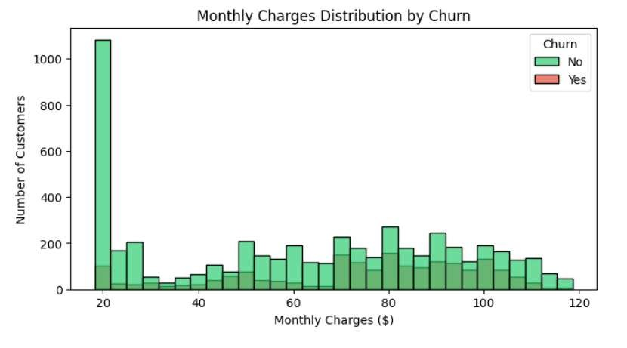
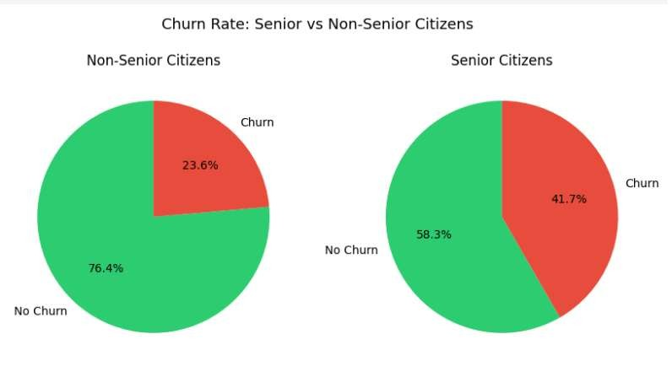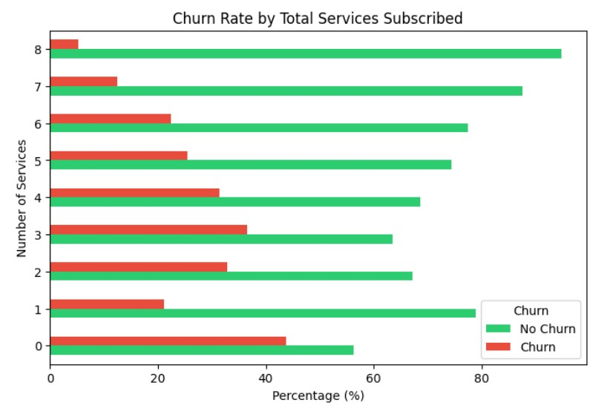
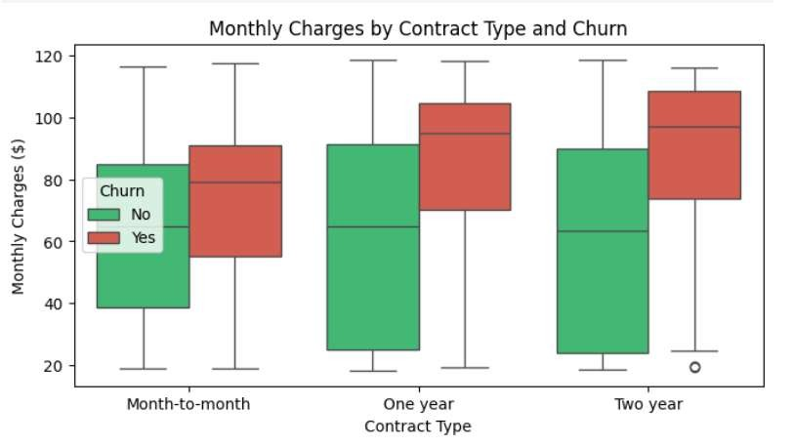
→Conclusions for each chart: Viz 1 — Churn Distribution 5174 customers stayed (73.5%) vs 1869 churned (26.5%). The dataset is imbalanced — this is why SMOTE is mandatory later.
Viz 2 — Churn by Contract Type Month-to-month customers churn massively compared to one-year and two-year contracts. Contract type is the single strongest predictor in the entire dataset. The company should push customers toward longer contracts.
Viz 3 — Churn by Internet Service Fiber optic customers churn the most despite — or because of — paying the highest prices. DSL customers are more stable. Customers with no internet barely churn at all.
Viz 4 — Churn by Payment Method Electronic check users churn at nearly 45% — the highest of any payment method. Automatic payment users (bank transfer and credit card) are the most loyal. Manual payment = less commitment.
Viz 5 — Tenure Distribution by Churn Churners are heavily concentrated in the first 12 months. The longer a customer stays, the less likely they are to leave. If you keep a customer past month 12 they are much safer.
Viz 6 — Monthly Charges Distribution by Churn Customers paying between 60100/month churn the most. Low-charge customers (20-40) are very stable. High monthly cost combined with a short-term contract is the danger zone.
Viz 7 — Senior Citizen Pie Charts Senior citizens have a 41.7% churn rate vs only 23.6% for non-seniors. Even though seniors are a small group (16% of customers), they are a high-risk segment that needs targeted retention.
Viz 8 — Total Services Horizontal Bar Customers with 0–2 services churn heavily. Customers with 5+ services barely churn at all. This validates the total_services feature we engineered in SQL — it is a strong predictor.
Viz 9 — Boxplot Monthly Charges by Contract Month-to-month churners have the highest and widest spread of monthly charges. Two-year customers have low and consistent charges regardless of churn status. High charges + no long-term commitment = highest churn risk.
5th : feature engineering & encoding
- Encoded ‘gender’ [ female:0 , male: 1]
- Encoded ‘churn’ [ yes: 1, No : 0]
- Encoded the binary columns as ['Partner', 'Dependents', 'PhoneService', 'PaperlessBilling', 'OnlineSecurity', 'OnlineBackup', 'DeviceProtection', 'TechSupport', 'StreamingTV', 'StreamingMovies'] as following:
{'Yes': 1, 'No': 0,'No internet service': 0
'No phone service': 0}

- Applied one – hot encoding on ['InternetService', 'Contract', 'PaymentMethod', 'MultipleLines']
6th : correlation Analysis :
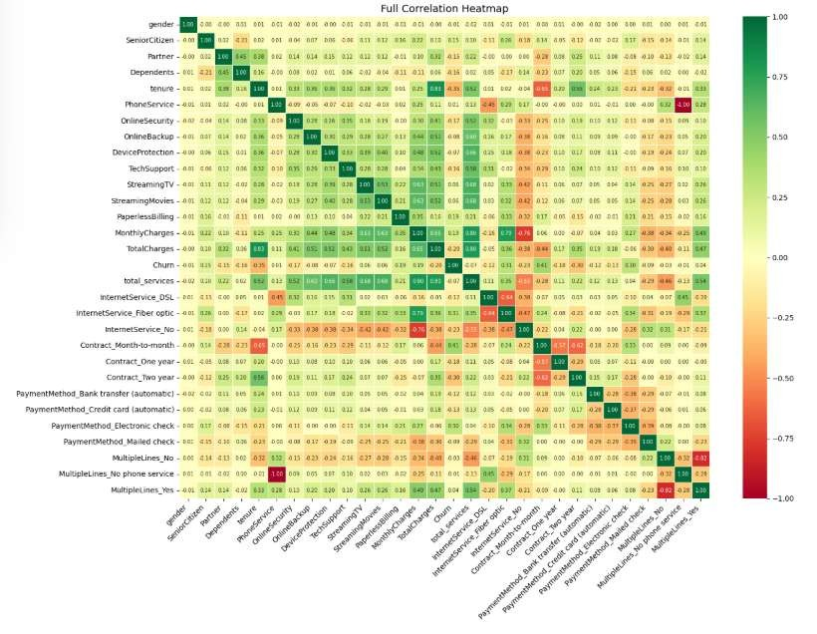
Correlation with target ‘ churn’:
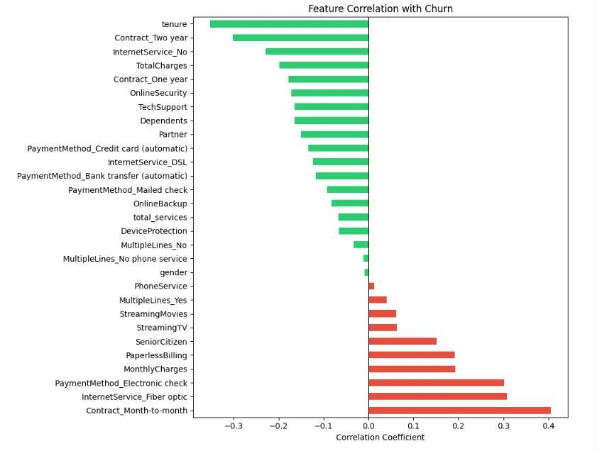

We’ll drop the weak features that are smaller than the threshold 0.05:
['MultipleLines_Yes', 'PhoneService', 'gender', 'MultipleLines_No phone service', 'MultipleLines_No']
7th . Handling class imbalance:
We used SMOTE (Synthetic Minority Over-sampling Technique) to handle imbalanced datasets by creating synthetic (artificial) samples for the minority class instead of simply duplicating existing ones.
Before SMOTE:
Churn
- 4139
- 1495

After SMOTE:
Churn
- 4139
- 4139
We used feature scaler ( MinMaxScaler() as a scaler ) to normalize numerical features so they all have the same scale, typically between 0 and 1.

8th Export Artifacts:
To ensure reproducibility and simplify the next phase of the project, all preprocessing artifacts were exported to an artifacts directory. The balanced training set (after SMOTE), the untouched test set, the fitted MinMaxScaler, and the ordered list of feature columns were saved. These artifacts allow the machine learning model and future prediction API to use the exact same preprocessing pipeline, ensuring consistent and reliable predictions without repeating the preprocessing steps.
Columns:
[
"SeniorCitizen",
"Partner",
"Dependents",
"tenure",
"OnlineSecurity",
"OnlineBackup",
"DeviceProtection",
"TechSupport", "StreamingTV",
"StreamingMovies",
"PaperlessBilling",
"MonthlyCharges",
"TotalCharges",
"total_services",
"InternetService_DSL",
"InternetService_Fiber optic",
"InternetService_No",
"Contract_Month-to-month",
"Contract_One year",
"Contract_Two year",
"PaymentMethod_Bank transfer (automatic)",
"PaymentMethod_Credit card (automatic)",
"PaymentMethod_Electronic check",
"PaymentMethod_Mailed check"
]

Milestone 2:
1st: Loading needed libraries & artifacts from milestone 1
2nd : Train pre-trained models ( XGBoost & Random Forest ): Random Forest and XGBoost were selected because they are powerful ensemble algorithms well suited for binary classification problems on structured data. They can model complex, nonlinear relationships between customer attributes and churn while handling mixed feature types effectively. Random Forest provides a robust baseline with good interpretability through feature importance, whereas XGBoost often delivers superior predictive performance by sequentially improving weak learners. Comparing both models helps identify the approach that best balances predictive accuracy and the ability to detect customers at risk of churning.
3rd : Inference script: we implemented a reusable function that takes a raw customer feature row and returns a churn prediction + probability. X_row: DataFrame with columns matching feature_columns exactly. Returns dict with prediction (0/1) and churn probability per row.
Example:

Customer 0: predicted=0 prob=0.0028 actual=0
Customer 1: predicted=1 prob=0.9467 actual=0
Customer 2: predicted=0 prob=0.2015 actual=0 4th: Evaluation report:
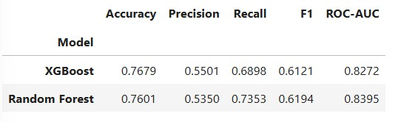

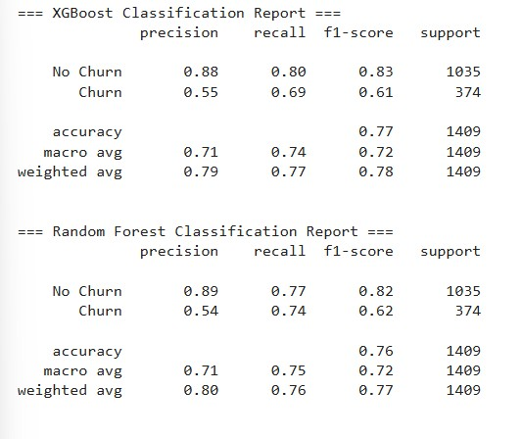
From the report above , we conclude that both models achieved similar overall performance, with accuracies close to 76–77%.
- XGBoost achieved the highest Accuracy and Precision, making it slightly better at avoiding false churn predictions.
- Random Forest achieved higher Recall, F1-score, and ROC-AUC, meaning it identified more churning customers and showed better overall classification performance.

5th : Confusion Matrices & Model Comparison Chart
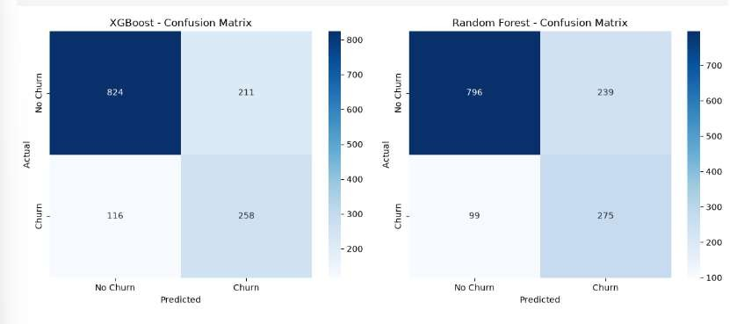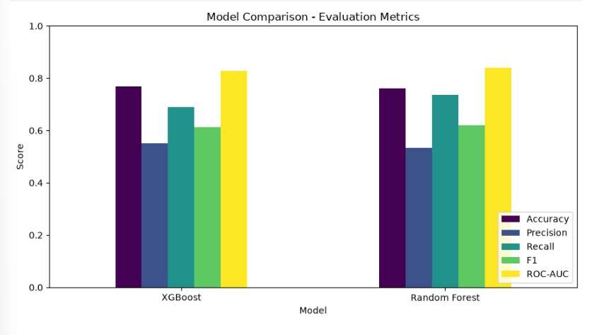

6th : Logistic regression
A Logistic Regression model was trained as a baseline classifier and evaluated using the same test set as the ensemble models. Its performance metrics, along with the training time, were added to a comparison table containing XGBoost and Random Forest. The models were ranked based on ROC-AUC, allowing an objective comparison of their ability to distinguish between customers who churn and those who remain. Using Logistic Regression as a benchmark helps assess whether the increased complexity of ensemble methods results in meaningful performance improvements.
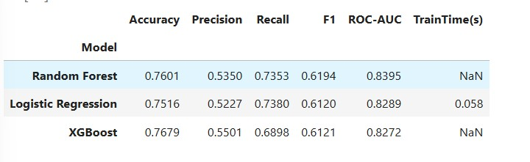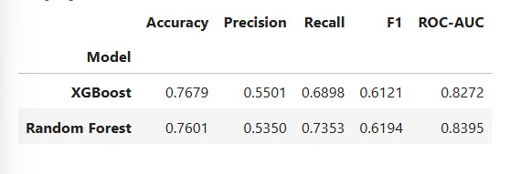

Best model by ROC-AUC: Random Forest Milestone 3:
The system includes:
- FastAPI REST API
- Dockerized deployment
- Apache Airflow orchestration
- Prediction logging
- Monitoring dashboard using Power BI
Technologies Used
- Python
- FastAPI
- XGBoost
- Docker
- Docker Compose
- Apache Airflow
- Power BI
- Pandas
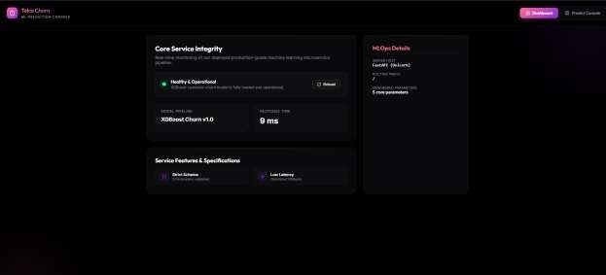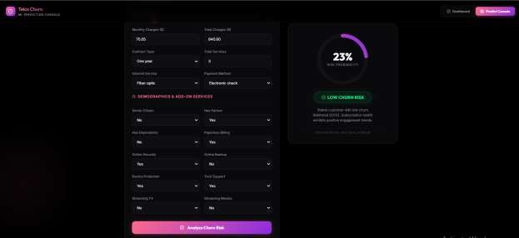
The dashboard above shows a real – time monitoring of our deployed production- grade machine learning microservice pipeline , it shows that machine learning model has been successfully deployed and is ready to receive prediction requests.
There are 2 pages:
→ Dashboard: Displays the system status and performance.
→ Predict Console: Allows users to enter customer information and receive a churn prediction.
1st Dashboard:
There is a response time that shows the time Api takes to process a prediction request , the workflow works in the following
User sends customer information
↓
FastAPI receives request
↓
Preprocess input
↓
Load XGBoost model
↓
Predict churn
↓
Return prediction
In our project, FastAPI acts as the bridge between the user interface and the machine learning model.
Instead of running the XGBoost model only inside a Python notebook, FastAPI exposes it as a REST API so that any application (web dashboard, mobile app, or another service) can send customer information and receive a churn prediction.
The main responsibilities of FastAPI in our project are:
- Receive prediction requests from the user.
- Validate the input data before it reaches the model.
- Apply the required preprocessing steps.
- Pass the processed data to the XGBoost model.
- Return the prediction as a JSON response.
- It uses Pydantic models to define the expected structure of incoming requests.
What is Uvicorn?
Uvicorn is a lightweight ASGI server that runs the FastAPI application and makes it accessible over the web.
Its main responsibilities are:
- Starting the FastAPI application.
- Listening for incoming HTTP requests.
- Forwarding requests to FastAPI.
- Returning responses back to the client.
The request flow:
┌─────────────┐
│ User │
└──────┬──────┘
│
▼
┌────────────────────────┐
│ Web Dashboard (GUI) │
└──────────┬─────────────┘
│
HTTP POST /predict
│
▼
┌────────────────────────┐
│ Uvicorn │
│ ASGI Server │
└──────────┬─────────────┘
│
▼
┌────────────────────────┐
│ FastAPI (main.py) │
└──────────┬─────────────┘
│
▼
┌────────────────────────┐
│ API Router │
└──────────┬─────────────┘
│
▼
┌────────────────────────┐
│ /api/v1/.../predict │
│ Endpoint │
└──────────┬─────────────┘
│
▼
┌────────────────────────┐
│ Pydantic Validation │
│ (Schemas) │
└──────────┬─────────────┘
│
▼
┌────────────────────────┐ │ Inference Service │
└───────┬────────┬───────┘
│ │
┌───────────────┘ └───────────────┐
▼ ▼
┌──────────────────────┐ ┌──────────────────────┐
│ Load MinMaxScaler │ │ Load Feature Columns │
└──────────┬───────────┘ └──────────┬───────────┘
└───────────────────┬────────────────────┘
▼
┌────────────────────────┐
│ Load XGBoost Model │
└──────────┬─────────────┘
│
▼
┌────────────────────────┐
│ Generate Prediction │
└──────────┬─────────────┘
│
▼
┌────────────────────────┐
│ Save Prediction │
│ data/predictions/ │
└──────────┬─────────────┘
│
▼
┌────────────────────────┐
│ JSON Response │
└──────────┬─────────────┘
│
▼
┌─────────────┐
│ User │
└─────────────┘

Project endpoints:
- Root Endpoint: GET / It serves the application’s gui
- Health check endpoint: GET /health
It verifies that the ML service is running correctly
- Prediction endpoint:
It receives customer information and returns a churn prediction →Airflow DAGs:
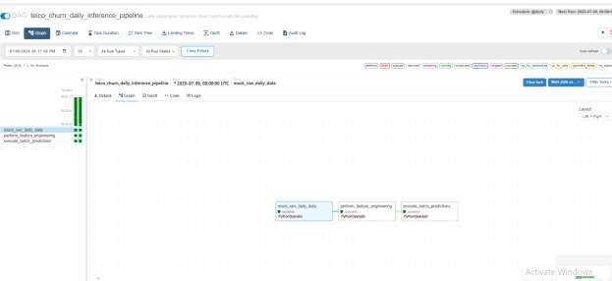
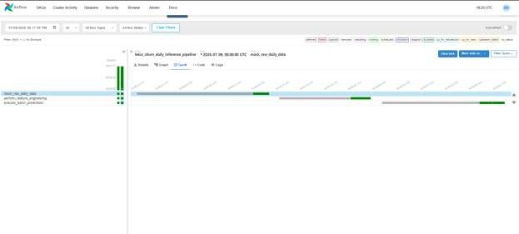
Automates the full daily batch churn prediction pipeline:

Task 1 → mock_raw_data_task:
Simulates pulling fresh customer records from a database. FIX: previously returned the same 3 hardcoded rows every run. Now samples real, held-out customers from Milestone 1's X_test.csv (never used in training) and reverses the scaling/encoding Milestone 1 applied, so Task 2 can re-process them exactly like fresh incoming data. Which customers get sampled is seeded by the DAG's logical date, so a given date always reproduces the same batch (safe for retries/backfills) while different dates genuinely differ.

Task 2 → feature_engineering_task:
Replicates the exact feature engineering from Milestone 1:
- Encodes categorical fields (Contract, InternetService, PaymentMethod)
- Calculates total_services the SAME way as Milestone 1 SQL Query 8
(8 services: 6 add-ons + PhoneService + InternetService)
- Applies MinMaxScaler (loaded from Milestone 1 artifact) to the 3 continuous columns

Task 3 → batch_inference_task:
Loads best_churn_model.pkl (winner from Milestone 2 evaluation), runs predictions on the engineered batch, saves results. FIX: previously overwrote a single fixed results file every run, so there was no history to plot drift against. Now keeps a dated snapshot per run AND a rolling history file. The history file is an idempotent upsert by run_date: re-running the same date replaces that date's rows only, so retries/backfills never create duplicates, and every other date's history is left untouched.
Flow: mock_data >> feature_engineering >> batch_predictions
Milestone 4 : Monitoring & Reporting What it does:
- Logs every prediction automatically to a CSV file for drift monitoring
- Provides data for Power BI dashboard showing churn trends over time
Prediction Logging (automatic)
Every call to `/api/v1/churn/predict` automatically appends a row to:
milestone3-api-deployment/milestone3/app/data/predictions/prediction_logs.csv Logged fields per prediction:
| Column | Description |
| `timestamp` | When the prediction was made |
| `tenure`, `MonthlyCharges`, `TotalCharges` | Core numeric features |
| `Contract`, `InternetService`, `PaymentMethod` | Key categorical features |
| `total_services` | Number of subscribed services |
| `SeniorCitizen`, `Partner`, `Dependents` | Demographics |
| `PaperlessBilling`, `OnlineSecurity`, `OnlineBackup`, `DeviceProtection`,
`TechSupport`, `StreamingTV`, `StreamingMovies` | Add-on services |
| `churn_prediction` | 0 = stays, 1 = churns |
| `churn_probability` | Model confidence (0.0–1.0) |

